Shabbos Stories for
Parshas lech lecha 5783
Volume 14, Issue 8 – 11 Chevron 5783/November 5, 2022
Printed L’illuy nishmas Nechama bas R’ Noach, a”h

For a free subscription, please forward your request to keren18@juno.com

Go Eat a Bagel!
By Rabbi Sholom Avtzon

During the lifetime of his father, the Rebbe the Tzemach Tzedek [Rabbi Menachem Mendel Schneersohn, 1789-1866], there was a stark difference between the [Rebbe] Maharash [Rabbi Shmuel Schneersohn, 1834-1882] and his older brother the Maharil. When the Maharil traveled (which was quite often), he would review his father’s maamorim as well as give brochos, while his brother refused to give a brocha.
Once they were going together on a mission of communal work and the Maharash said to him, “I will not go with you if will conduct yourself in a Rebbeshe way. Bury your Rebbeshkeit here under this stone and you could retrieve it when we return.”
Having no choice, the Maharil agreed.
The chassidim were anticipating that he would say Chassidus and then allow them to have a yechidus, where he would give brochos. But to their tremendous disappointment, he informed them that he can’t.

A Lady Wanted a Blessing for a Child
In one town, a lady who was married for some years and was not blessed with a child hoped to receive a blessing. She decided to wait next to the wagon. As they came out of the Shul she approached the Maharil and requested a blessing. Keeping to the agreement the Maharil replied that he can’t and she should go to his father the Rebbe in Lubavitch.
However, she wasn’t happy with this and she continued to implore for a brocha. The Maharil also was firm that he can’t and climbed upon the wagon.
Seeing that they are preparing to leave, she took a thick beam or piece of wood and placed it between the spokes of one the wagon wheels to prevent them from going. The Maharil turned to the Rebbe Maharash, implying that the Maharash has to take care of the situation.
The Maharash told the lady “gei ess a bulka- go eat a bagel.”
Satisfied that she received a brocha she removed the beam, and they went on their way and took care of the mission they were given.

The Husband Brought a Large Cake to the Rebbe Maharash
Almost a year later this lady’s husband came to Lubavitch with a large cake to thank them for the brocha. In fact, he exclaimed we were blessed with twins.
Somewhat surprised the Rebbe Maharash asked, "Twins?"
"Yes Rebbe, my wife ate two bulka’s."
The Maharil heard what happened and said to his brother, “You told me not to give any brochos, because we are not the Rebbe, and then you gave the lady a brocha?!
The Rebbe Maharash replied, “I didn’t give her a brocha, I was telling her to leave us alone.
However, she thought I gave her a brocha and it was her Emunah that came and created the brocha.”

Reprinted from the Parshas Haazinu Weekly Story of Rabbi Avtzon, a veteran mechanech and the author of numerous books on the Chabad Rebbeim and their chassidim. He can be contacted at avtzonbooks@gmail.com

The Spilled Wine
On the Sefer Torah

A well-known askan, communal personality, who was involved in many organizations and reached out to assist those in need, regardless of their affiliation with a specific brand of Orthodoxy, took upon himself to commission the writing of a Sefer Torah. It had always been his dream to do something personally for the Torah. He went out of his way to arrange to have the Torah written by one of the finest, most credible sofrim on parchment that was flawless. It took some time and ultimately ended up costing more than he had initially expected, but the finished product was an absolute, unblemished beauty. Indeed, it was so perfect that it was hard to believe it was the work of a human being.

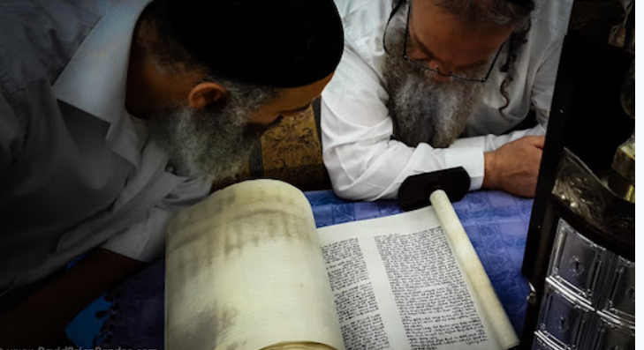

On the day of the culmination of the writing, the last few letters were to be filled in by dignitaries and close family friends. Among them was Horav Mordechai Zukerman, zl (Mashgiach, Yeshivas Chevron), and another Rav from Yerushalayim. When it came the turn for the Rav to fill in his letter, his sleeve caught on the bottle of wine which had been prepared for the l’chaim and the unthinkable happened: some wine spilled on the white border of the last yeriah, sheet of parchment.
Not only was the parchment now stained, the odor of wine that emanated from the parchment was clearly evident. One can only begin to imagine the feelings of disconcertment that overwhelmed the Rav. He was acutely aware of the effort and expense that the host had expended in order to produce such a fine Sefer Torah, and he had spilled wine on the last sheet.
Incidentally, the host said nothing concerning the occurrence. He understood and accepted the fact that the last sheet would need to be replaced. After the incident, the Rav accompanied Rav Zuckerman home.

Pain Written All Over the Rav’s Face
The Mashgiach noticed the pain written all over his friend’s face and remarked, “I have a tradition (which he had heard from earlier gedolim, Torah giants. He had been the student of both the Chafetz Chaim, zl, and Horav Avraham Grodzenski, zl). When one acts in good faith, with noble intentions, no takalah, mishap, will result from it. Do you hear me? Nothing adverse will arise from it. Everything is guided from Heaven Above. You will see that (the spilling of the wine) whatever occurred was for a reason. Everything is only for the good!”
The next morning, a festive celebration a large gathering that included distinguished personages, friends and family. Indeed, people from all walks of life joined in this seudas mitzvah, celebratory meal, following the fulfillment of a mitzvah. The Rav and Rav Zuckerman were among the invitees. The Rav just sat pensively, reviewing what had occurred the previous night.

The Holocaust Survivor Who Became an Apikores
As in all grand dinners, there were speakers and speakers. One of the last men to speak was a cousin who had come in from America especially for the occasion. He said, “I am a Holocaust survivor, and, as such, I have lost my faith in Hashem (chas v’shalom, Heaven forbid). I went through much and witnessed atrocities that defy human rationale. Nonetheless, out of respect and admiration for my relative, I came to join in his celebration (although it means nothing to me). I even wrote a letter in the Torah!”
As soon as the man said this, Rav Zuckerman looked at the Rav and said, “See, I told you that the wine was spilled for a reason! This man has just declared publicly that he is a nonbeliever. Hence, he is an apikores, guilty of heresy. As such, the letter that he filled in is pasul, invalid. That last yeriah would have had to be changed. Who knows when his lack of beliefs would have been discovered? Hashem protected His Torah, and He used you as His vehicle. If Hashem causes a takalah to happen to a person, it is for a good reason and serves a noble purpose.”

Reprinted from the Parshas Vayeilech 5783 edition of Rabbi A.L. Scheinbum’s Peninim on the Torah.
Last Chance in the Heavenly Court for the Irreligious Woman

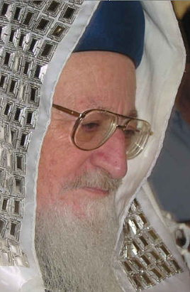
Rav Mordechai Eliyahu, zt”l

Rav Mordechai Eliyahu, zt”l, was the Rishon L’Tzion, the chief Rav of Eretz Yisroel. Every Friday Harel Hatzroni would go to visit Rav Eliyahu after Shacharis, as that was the time when he would read the letters of the many people who turned to him for advice.
Harel would ask his questions in person. One Friday morning, while he was waiting in line to speak with Rav Eliyahu, someone said to the Rav that a woman was waiting outside and she would like to see the Rav. She said that she had died this week, and she has seen Rav Eliyahu in the Bais Din Shel Maalah, in the Heavenly Court above.

She Had Died in the Hospital and Miraculously Came Back to Life
Rav Eliyahu was not fazed by what he had just heard. The man continued, “She wants to ask the Rav a question.” Rav Eliyahu went outside to see her. Waiting there was a woman who didn’t appear to be religiously observant. The man who had come to speak with Rav Eliyahu said that she was in the hospital just a few days ago. Apparently, she hadn’t been feeling well, and her condition suddenly and rapidly deteriorated. Within moments, she had passed away.
After the doctors had determined that she had died and the family had signed all the forms, they noticed that she started waking up! She related that she had experienced clinical death and had been to the Heavenly Court above.
At this point the woman became very emotional and began to tell the story herself. “I began to cry. I told the Heavenly Court, ‘Not long ago, I gave birth to a daughter, and I also have a son. I want to raise my children. I don’t want my children to be orphans.
Please, I ask you to give me another chance.’ But they didn’t agree.”
She looked at Rav Eliyahu and said, “And suddenly you came and said to me, ‘If you observe the laws of modesty, by wearing a head covering and everything that a woman needs to do, you can come back down to this world. Do you take it upon yourself to do this?’ I told you that yes, I would take it upon myself so that I could return below. And then in Heaven it was announced that if Rav Eliyahu said that I could return, so it would be.”
Rav Eliyahu didn’t deny anything. The woman finished with her story and said, “And now I’ve come, because I want the Rabbi to tell me what to do.”
Rav Eliyahu responded, “I have already told you there what to do. Now go do what I told you to do.”
The woman nodded, like someone who was once more taking it all upon herself, and Rav Eliyahu went back in the Shul. Harel said, “It’s possible that she came just to confirm that everything really happened, and make sure that she hadn’t just imagined it all.” Harel concluded, “It wasn’t imagination. With my own eyes and ears, I saw and heard Rav Eliyahu’s reaction. I was left stunned and in awe of Rav Eliyahu!”

Reprinted from a recent email of Rabbi Yehuda Winzelberg’s Torah U’Tefilah.

Complaining about
Too Many Simchas
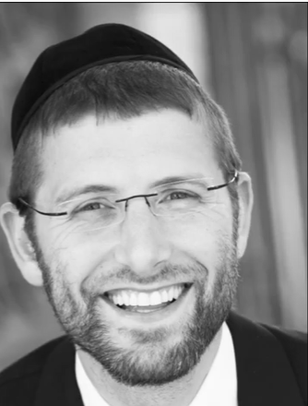
Rabbi Yoel Gold

Rabbi Yoel Gold told a story in his Behind the Music video about Abie Rotenberg, a singer who wrote a song with Rabbi Yaakov Kaplan. Rabbi Kaplan was sitting at a table at a wedding, and the people were complaining about all the parties they had to go to that week.
“We have a wedding on Monday, a bar mitzvah on Tuesday, a sheva berachot on Wednesday, an engagement on Thursday…”
An elderly man at the table banged his hand on the table, shaking it, and said, “You people are complaining about going to a simcha? I remember a time when we didn’t know if there would ever be Jewish semachot ever again.” He began to tell his story.
In 1945 when he finished serving for the Russian army, this man returned to Vilna to check if he had any living family left. There were 400 Jewish survivors back in Vilna, and they all decided to go to shul on Simchat Torah. The shul was in ruins. The books were destroyed, the Sefer Torah was nowhere to be found, and the people were truly heartbroken after the war.
The man saw a little boy holding his father’s hand, and he said to the boy’s father, “I just traveled hundreds of kilometers, and I had not seen one Jewish child. Can I please pick him up on my shoulders and dance with him to celebrate Simchat Torah?”
As much as Hitler tried to destroy our people, he failed miserably. And even without a Sefer Torah, and with only two children among 400 people, the survivors of Vilna danced around the bimah for hours. They carried the children on their shoulders, knowing that they were holding the future of B’nei Yisrael, and that the nation would survive and flourish.

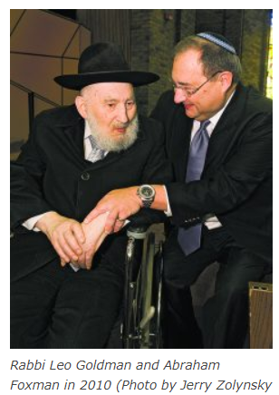

Reprinted from the Parashat Vezot Haberacha/Simcha Torah 5783 email of Jack E. Rahmey based on the Torah teachings of Rabbi Amram Sananes. [Editor’s Note: the boy the Russian soldier picked up was Abe Foxman who served as director of the Anti-Defamation League for many years. The Russian soldier was Rabbi Leo (Eliyahu) Goldman who for many years lived in Detroit. In 2010, two years before his petirah, Rabbi Goldman was able to once again see that “little” boy – Abraham Foxman.

The Haunting Shofar
Blast in Mumbai, India

Rabbi Paysach Krohn tells a remarkable true story he heard while spending weekend in Boca Raton, from Rabbi Phillip Moskowitz.
A cousin of his had grown up irreligious and gone to secular schools, although he possessed a rudimentary knowledge of what Shabbat, Kashrut and Jewish practice involved. Nonetheless, his upbringing lent itself to little religious affiliation, and once he had graduated high school, he entered the Israeli army and continued remaining irreligious.
Given the immense pressure of the army, once he had finished, he decided to take some time off and tour Mumbai, India. Yet the more time he spent out of Israel, the less religious he became. Sooner than later, he had dropped everything and was completely out of touch from any and every vestige of Jewish life.
Once night, as he sat in a bar in Mumbai with his friends, he heard a strange, bellowing sound. He recognized it faintly, though he couldn’t put his finger on what it was. Waiting just seconds more, he heard it again. And then it clicked. It was the sound of the Shofar.
He immediately made his way outside the bar and waited to hear the sound again. He couldn’t make out from where it had come just seconds ago. But then again, from down the block, the reverberating sound of the Shofar went off. Shaken, he immediately headed back to his apartment and began making phone calls.
What was going on? Why was he hearing the Shofar being blown? Upon inquiry, he learned that the prior day was none other than Yom Kippur, and the sounds of the Shofar had been blown by the rabbi of a small shul just down the street, indicating the end of the holiday.
He couldn’t believe it. He had forgotten that it was Yom Kippur. True, he had just about zero connection to Judaism, but Yom Kippur was Yom Kippur. The holiest day of the year had just gone by, and he hadn’t had a clue. With a heavy heart full of remorse over how far he had drifted from his family roots of Judaism, he began tearing up. He had become so unaffiliated as a Jew that it pained him to realize where he was and what he was doing with his life.
Deciding that it was time for a change, he began packing his bags, and booked a ticket to Israel. The next morning, he left Mumbai, returned to Israel and expressed interest in learning about Judaism.
His family could not believe that such a sudden and drastic shift could have occurred, though nothing deterred him from progressing forward in his studies. For the next several years, he spent his days learning Torah and creating a new, religious life for himself. He eventually married and began raising a religious family. Everything had changed from that one night when he heard the sound of the Shofar and it had literally awakened him to turning his life around.

Reprinted from the Shabbat Shalom from Cyberspace Parshast Haazinu-Sucot 5783 email of Rabbi David Bibi.

The Direction Change
By Rabbi Nachman Seltzer

My daughter Sara had been dating for a long time. I felt as if I’d become acquainted with every shadchan in Eretz Yisrael, and all of them had become my personal friends. Though I had tried for a long time to narrow down what Sara was looking for, the only thing I knew for sure was that the boy had to be a fluent English speaker and not Israeli-born.
At some point, I realized that I didn’t know what to do anymore. I no longer felt comfortable calling shadchanim when my daughter was so unclear about what she wanted. One afternoon, I traveled to the Kosel to pour out my heart to Hashem. “I cannot do this anymore,” I said to Hashem. “I don’t know what she wants, and neither does she. You, however, know exactly what she wants. Please send him!” I davened for a while longer and then I left the Kosel, satisfied that I had told Hashem what I’d come to say.
• • • • •
What Kind of Bad News?
The situation took a twist in a different direction a few months later. We had been scheduled to go to the Beit Shemesh home of one of our daughters for a Chanukah party that night and were already on the way when Sara’s phone rang. She answered, and her face froze. There was no question in my mind that she’d just received bad news. The only question was: what kind?
When she finally got off the phone, she told us, “Tonight’s plans are changed. The party is not happening at Avigail’s house.”
We asked her what had happened. She explained that our other daughter had called to tell us that Avigail had just been taken to the hospital. Avigail was expecting a baby at the time, and clearly something had gone wrong. It looked like Avigail was going to lose the baby.
• • • • •
A Zechus for Avigail’s Baby
As we drove toward Beit Shemesh, I could see that Sara was lost in thought. Soon she turned to me and said, “I’ve been saving up my money for a while. I’d planned on making a major donation to one of the big tzedakah sites in the merit of finding my zivug soon. But now I think I’m going to change my mind and donate the money as a zechus that Avigail’s baby should be born healthy and complete.”
She then turned to her brother, who was also in the car, and suggested that he do the same. I was very impressed that Sara would take so much money — money that she had planned to use for herself — and use it for something else. But there was no question in her mind that this was what she wanted to do.
Baruch Hashem, the baby survived. His parents called him Ariel. Sara was naturally thrilled by the turn of events and went out of her way to develop a relationship with her nephew.
• • • • •
Sara Would Stay with the Baby in the Hospital Overnight
About eight months after his birth, Ariel developed an infection and had to be hospitalized. With four other children at home, it was very complicated for Avigail to stay with him at the hospital during the nighttime hours. To ease the load, Sara stayed in the hospital with Ariel during the daytime hours and slept overnight with him as well. Sara was there for him when he woke up and cried because he was in a strange place, and she was there to hold him and comfort him.
Every morning, the doctor would make his rounds and ask the family members what had occurred during the night. Since Sara was the family member who had been with Ariel, it was she who gave the doctor the report. After a week, Ariel recovered from his infection. The doctor gave him a clean bill of health and permission to return home. With her nephew back in his daily routine, Sara returned to her life, too.
• • • • •
A Phone Call from the Baby’s Doctor
A few days later, Avigail’s husband, Yehuda, received a phone call.
“Hello?”
“Hi, is this Yehuda?”
“Speaking. Who is this?”
“It’s your baby’s doctor, Itamar.”
Now it just so happened that Yehuda and Itamar had gone to the same yeshivah together and had known each other for years.
“Thank you for taking such good care of my baby,” Yehuda told his old friend.
“You’re very welcome.”
“So, what can I do for you?”
“This is going to come as a little bit of a surprise,” the doctor said, “but I would appreciate it very much if you’d be willing to ask your in-laws if they would look into me as a prospective husband for your sister-in-law.”
“You mean the sister-in-law who stayed with my baby at the hospital?”
“Yes. I’ll send you my résumé, and of course you can check with our rebbeim whom I’ve kept in touch with over the last ten years…”
• • • • •
But He’s Israel and Not a Fluent English-Speaker
Yehuda didn’t waste any time. After he got off the phone, he called me up and told me the entire story.
“But Yehuda,” I said, “you know what the problem is going to be?”
“Yes, I know. Itamar is Israeli, and Sara only wants someone English-speaking.”
“Exactly.”
“Still, maybe tell Sara what happened and ask her. Let me know what she says.”
So, I called Sara and told her that someone had expressed interest in meeting her.
“Who, Mommy?”
“The doctor who took care of Ariel in the hospital.”
“Tell him yes!”
“But he’s Israeli.”
“Doesn’t matter.”
And it didn’t.
From time to time, I think about my daughter’s shidduch and how it came about. I think about the fact that she’d always insisted that Israelis weren’t for her, and how she ended up marrying one. I think about the fact that I told Hashem that I didn’t know what to do and asked Him to take over — and He did. Of course, I also think about the fact that my daughter took all the money she’d intended to give to tzedakah as a merit for herself and gave it instead as a merit for her sister and unborn nephew. And how that baby was the one who actually introduced her to her husband. I think about all these things from time to time. Then I smile. Because it is just so obvious that there is Someone up there running the world. - As heard from Sara’s mother.

Reprinted from the Sukkos 5783 email of At The ArtScroll Shabbos Table. Excerpted from the ArtScroll book “I Have an Amazing Story for You! 4)

The Last Circumcised King
By Rabbi Yaakov Asher Sinclair

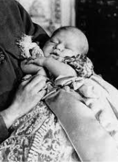
King Charles as a baby

King Charles III and I don’t have a lot in common. And even though as a child, I remember strongly identifying with him, I realized pretty soon that the silver spoon in his mouth was considerably more-silvery than mine. We do have one similarity, though. We're both circumcised. King Charles and before him, the sons of George V – Edward VIII, the Duke of Windsor; George VI; Henry, Duke of Gloucester; George, Duke of Kent; and Prince John were all circumcised.
Now, legend has it that Queen Victoria believed that she was descended from King David and thus commanded her family to be circumcised. Now, whether this is true or not, in December 1948, Rabbi Dr. Joseph Snowman was invited to Buckingham Palace to circumcise Prince Charles. In fact, circumcision was widely performed on British middle-and-upper class male infants from the 1890s through the 1940s.
Things have changed a bit since then.

Anti-Semitic Ballot Proposal to Outlaw Circumcision
In 2010, activists against infant circumcision began an initiative to put a measure on San Francisco's November 2011 ballot that would ban all non-medically necessary circumcisions of minors. The group also published a rabidly anti-Semitic comic about a “superhero who battles circumcisions.”
Hermann Rauschning in his book Gespräch mit Hitler, published in English as “Hitler Speaks,” writes that Hitler said to him, “Conscience is a Jewish invention. Like circumcision, it mutilates man.” It's interesting that Hitler linked conscience with circumcision. Conscience requires us to think about the consequences of our actions, to focus on the future and not the present. The body's interest is only the present. The place of the circumcision, brit milah, is the place from which our future flows.

The Hebrew Letters for the Word Rechem
(Womb) is the Same as Machar (Tomorrow)
The Hebrew name for the womb is rechem. You can rearrange the letters of rechem to read machar, which means tomorrow. The word in Hebrew for circumcision is Brit Mila. But it also means a covenant. Avraham Avinu made a brit, a covenant, with G-d. And in this covenant, Avraham dedicated everything he would ever be to his future, his progeny, and their progeny, throughout all the generations to G-d. And G-d, so to speak, dedicated His future, everything that He would ever be in this world, to come about through Avraham. Avraham Avinu and his children, the Jewish people.

Reprinted from the Parashat Ki Tavo 5782 Newsletter of TorahAnytime as compiled and edited by Elan Perchik.

